

Kindergarten Halloween Information 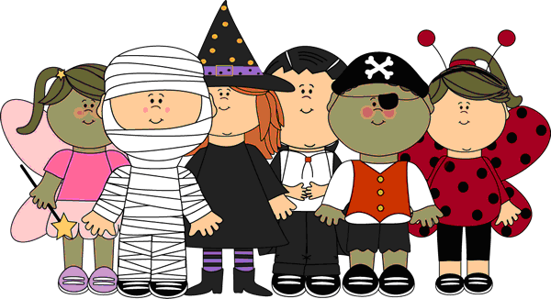

On Wednesday, October 31st, we will celebrate Halloween in our classrooms. The children ARE allowed to wear their costumes to school. The room parents have been busy organizing a fun party for the children which will take place Wednesday afternoon.

**Kindergarten Halloween Rules:**

* Costumes must be comfortable.
* Leave all props at home: wands, gloves, brooms, whistles, plastic swords, light sabers, etc.
* No masks.
* Gym shoes must be worn.  We will still have recess.
* Please do NOT send your child with candy to pass out**.** We will have plenty of treats at our party!
* Make sure your child wears a costume that is ‘bathroom friendly’.

Attached is a Halloween candy sort worksheet. After all the Halloween fun, please help your child complete the activity and turn it in by Friday, November 2nd. Ask your child which as the most, the least.

As always, any questions, just ask!

The Kindergarten Team