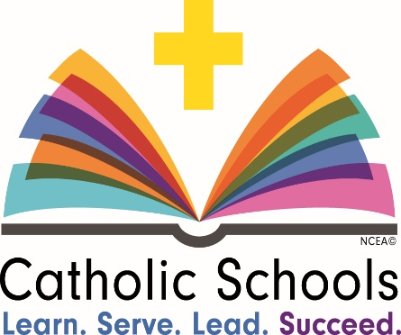
January 26th – January 31st is Catholic Schools Week. Listed below are the activities that will take place at St. Cletus School to celebrate how we learn, serve, lead and succeed!
Catholic Schools Week
Join us as we celebrate how we
Learn! Serve! Lead! Succeed!
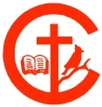

Catholic Schools Week Activities:

Sunday, January 26th | Mass: 9:30 AM & Open House: 10:30 AM - 1:00 PM  Please join us for Mass followed by an open house at the school for current and prospective families. St. Cletus students should attend with their families and wear their school uniforms.
Monday, January 27th | Crazy socks & shoes with uniform!  Wear your uniform with any socks and shoes you’d like – just remember to be safe and if you have gym…gym shoes are required.
Tuesday, January 28th | Dress as your favorite book character!  Dress up and bring in your favorite book to help others see how you Learn and Succeed as a reader. Remember to be appropriate and if you have gym….gym shoes are required.  Bring in a book to donate to those in need!
Wednesday, January 29th | Teacher Appreciation Day & Mass: 10:30 AM  We will attend Mass together, and teachers will enjoy the FSA sponsored luncheon.
Thursday, January 30th | Student Appreciation Day: Books, Board Games & Buddies!  Teachers will find a time during the day to share some special time with their buddies to show how we Lead!  Dress comfortably, according to the dress down code, to have some fun on the floor.
Friday, January 31st | Red & White Day – Souper Day!  We’ve got spirit, yes we do, we’ve got spirit how ‘bout YOU!?  Students in grades 1-8, wear your assigned red or white color along with gym shoes for the red and white volleyball games, which take place throughout the school day. Spirit wear for everyone else!  Bring in a soup can to show how we Serve others on our souper day!

