Name: _____________________________________________________________
Directions: Pick three different kinds of candy. Write the name of the candy on the lines in each circle. Be sure to use a pencil. Sort your candy and then tally how many you have of those three candies, then write the number in the box. Be sure to answer the most/least questions when you’re done with your tallies. Turn this page in for a sticker!
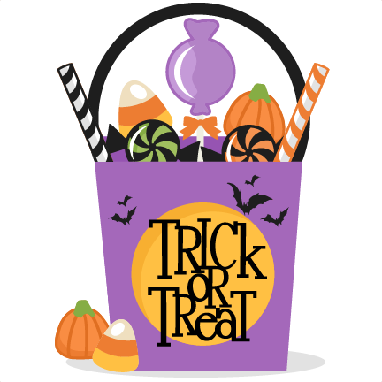
I had the LEAST of this candy:
________________________

I had the MOST of this candy:
________________________

