Life Is A Puzzle Solve It Drug Free!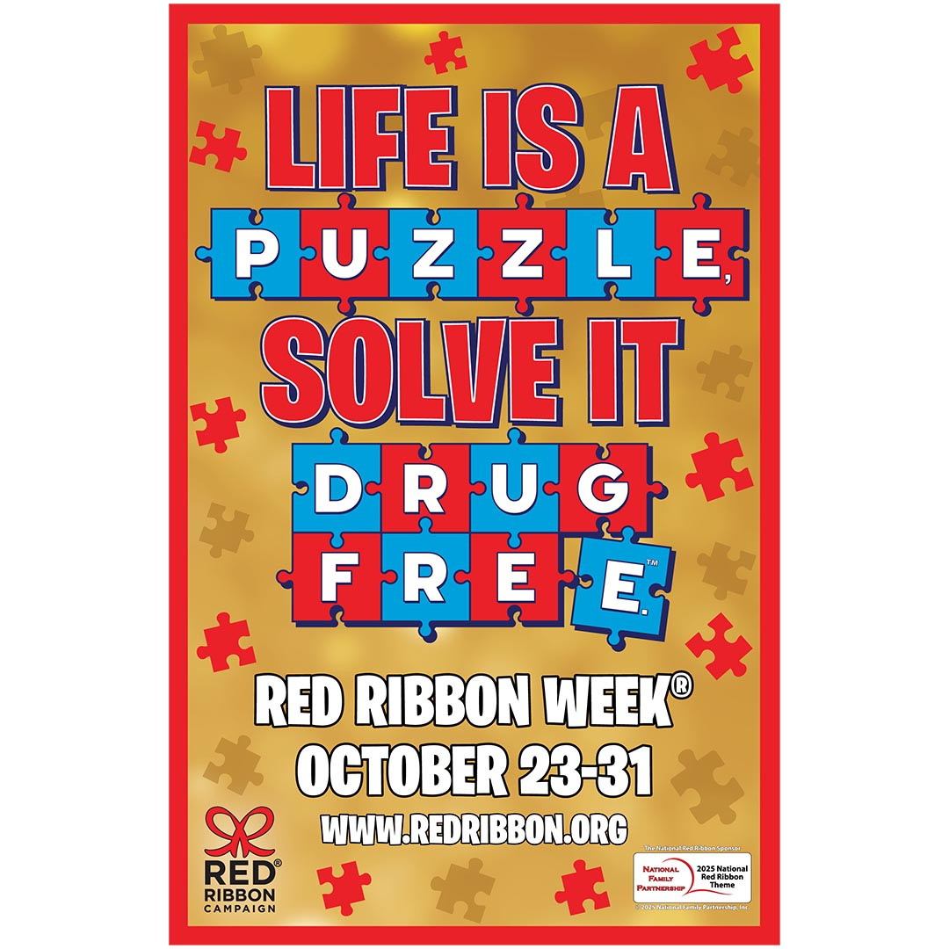
Red Ribbon Week Activities
October 27th – October 31st
Monday – Let’s solve This! Breast Cancer Awareness PINK Dress Down Day for $1 to help work toward solving this disease!
Tuesday – Regular uniform day. Crazy Sock Day! Buddies and puzzles or games! Bring a canned/boxed food item(chili, cereal, soup, flavored Rice packets) !
Wednesday – It’s Puzzling! Decades Day - dress from your favorite decade - 80’s, 70’s, 60’s, 50’s???! Create a puzzle collage as a class.
Thursday – It's a Mystery - Let’s Solve It! Hawaiian shirts and shorts/ comfy clothes day !
Friday – We Are Drug Free! Dress in your Halloween Costume - follow the costume guidelines. Parties and Parade!
IT’S A GREAT DAY TO BE A CARDINAL!

